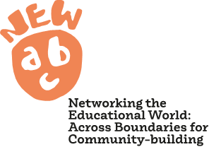

Pilot Action: Empowering Young Translators
Pilot Action Leads: OU & OBU

Young Translator Club – Session 1
Delivery date and activity lead(s) | Taster session
Key learning theme

Aims & objectives

Breakdown of session
Key activities (e.g. ice breakers, PAR activities, training, evaluation etc.)
Materials and data recording equipment (e.g. paper, post its, markers, notepads, recorders, cameras etc.)
Hospitality (e.g. drinks, food, snacks)

Detailed overview of session:

Team members:
Young translators:

