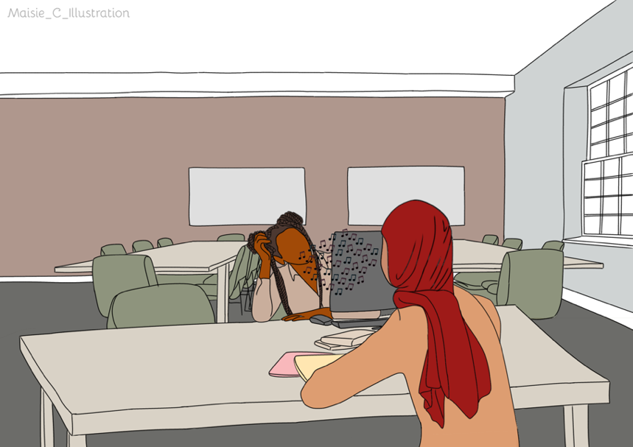
Stories of Young Translating

You are ALL invited to take part in our Storyboard and Writing Competition!!!

Have you ever translated for someone else?
Has someone ever translated for you?
Have you ever seen someone else translating?

You might have translated for family or friends in places like school, the bank or the doctors. Perhaps you translate on the phone or in person. You might have seen when someone else has translated. Perhaps someone translated for you while you were on holiday.

When you have thought of a memory you can:

Draw your experience in the storyboard and then tell us what is happening

Not sure about doing a storyboard? You can write about the situation instead.

Not sure about writing? You can record an audio podcast instead

Prizes to be won
4 Prizes to be won

Prize giving day: Assembly on the [ADD DATE]

