

FEEDBACK

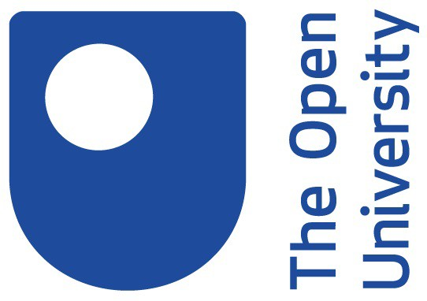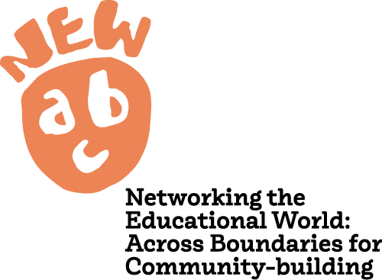

NEW-ABC has received funding from the European Union’s Horizon 2020 research and innovation programme under grant agreement NO 101004640.

The views and opinions expressed in this presentation are the sole responsibility of the author and do not necessarily reﬂect the views of the European Commission.

What did you think of today’s presentation? What did you enjoy the most about being involved?

What could we have done differently?

How did you feel when presenting your work and Club experiences to members of your school’s senior leadership team?

In your opinion, the Young Translators Club project has been about