Our young people also told us of situations where learning and speaking a foreign local language, might experience difficulties in relation to grammar or pronunciation. They described being picked on or made fun of by other students.

CHALLENGE: Our young people told us that speaking a different language can also lead to experiences of bullying and racism.

This might prevent young people from confidently practicing their new language in front of others, and negatively impact their emotional well-being and sense of belonging.

They suggested ways of supporting young people's well-being:

Having access to a safe, multi-cultural space to express and share such experiences: setting up an after-school Club with activities that offer different forms of expression and welcome diverse backgrounds, skillsets and interests (e.g., media and digital art, learning about different cultures, drawing and storytelling activities).
What kind of changes would make a difference for young translators in your organisation? Can you think of a theme you’d like to focus on?

We explored ‘Our young translating, our feelings’. When we translate for others, we can feel very proud and pleased to do it. Sometimes, we can also feel bad, especially if people are not nice or patient.
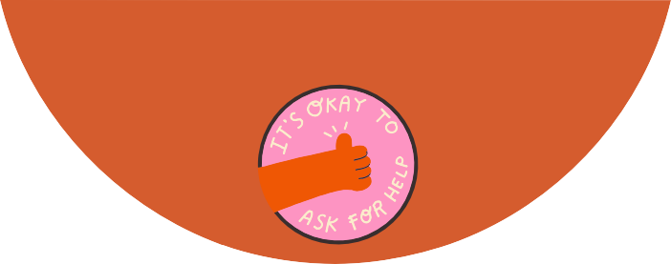

What support might schools offer in such situations? Ask the young people if they are happy to help.

We think it is important to:

Support students to raise awareness of young translating in school
Older students setting up socialising activities
Being aware that language expression can lead to negative comments (including racism)
Being aware that young translating involves people’s feelings and emotions

The Young Translators Club

Created by
the Young Translators Club
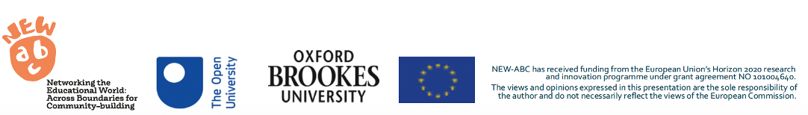

This leaflet was co-designed by members of a school Young Translators Club as part of the NEW ABC project.
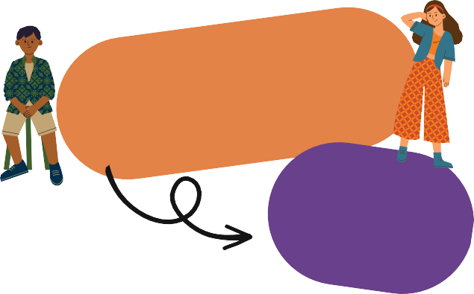

The leaflet aims to offer insights into the experiences of children and young people who speak more than one language(s), and who regularly translate and interpret for peers, family, and their local communities.
The young people hope that this guide will:

- Explain how young translators might feel
when arriving at a new school.
- Offer advice to better support other young translators in educational and learning spaces.
- Raise awareness about young translating as a complex caring activity.

We are a group of students who speak two or more languages and regularly translate for family members and/or friends in school. Together, with university researchers we’ve been meeting after school to explore what it means to be a young translator.

We’ve been learning a lot about what translating involves, how it makes us feel, the things we find challenging and how it helps us care for others.

We’ve shared a few challenges that might help you understand what being a young translator involves. We’d also like to offer some suggestions about how educators can better support their comfortable transition into their learning environment.

Language is a key tool for socialisation and personal expression. Not speaking the local language can be challenging for young people - especially as there are differences between written and spoken forms in certain languages.

CHALLENGE: Our young people told us that arriving at a new
school and trying to find where you belong can take some time, especially when one doesn’t speak the local language.

They suggested ways of supporting young people’s language-learning journey:

Be kind, patient and find supportive resources: (e.g., online free resources such as google translate through the school’s IT equipment).

Set up after-school activities: (e.g., film screenings followed by a Q&A discussion, can support language learning as well as offer opportunities for socialisation and informal conversation with peers).

Set up a Buddy system: being paired up with another student -especially someone who can speak the same language, to act as their buddy-mentor, offer advice and help navigate school life.

