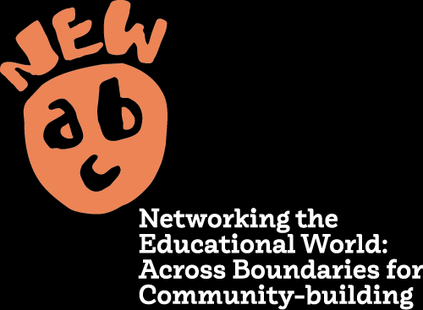 



ESCAPE ROOM

NEW ABC has received funding from the European Union’s Horizon 2020 research and innovation programme under grant agreement No 101004640.

The views and opinions expressed in this document are the sole responsibility of the author and do not necessarily reflect the views of the European Commission.

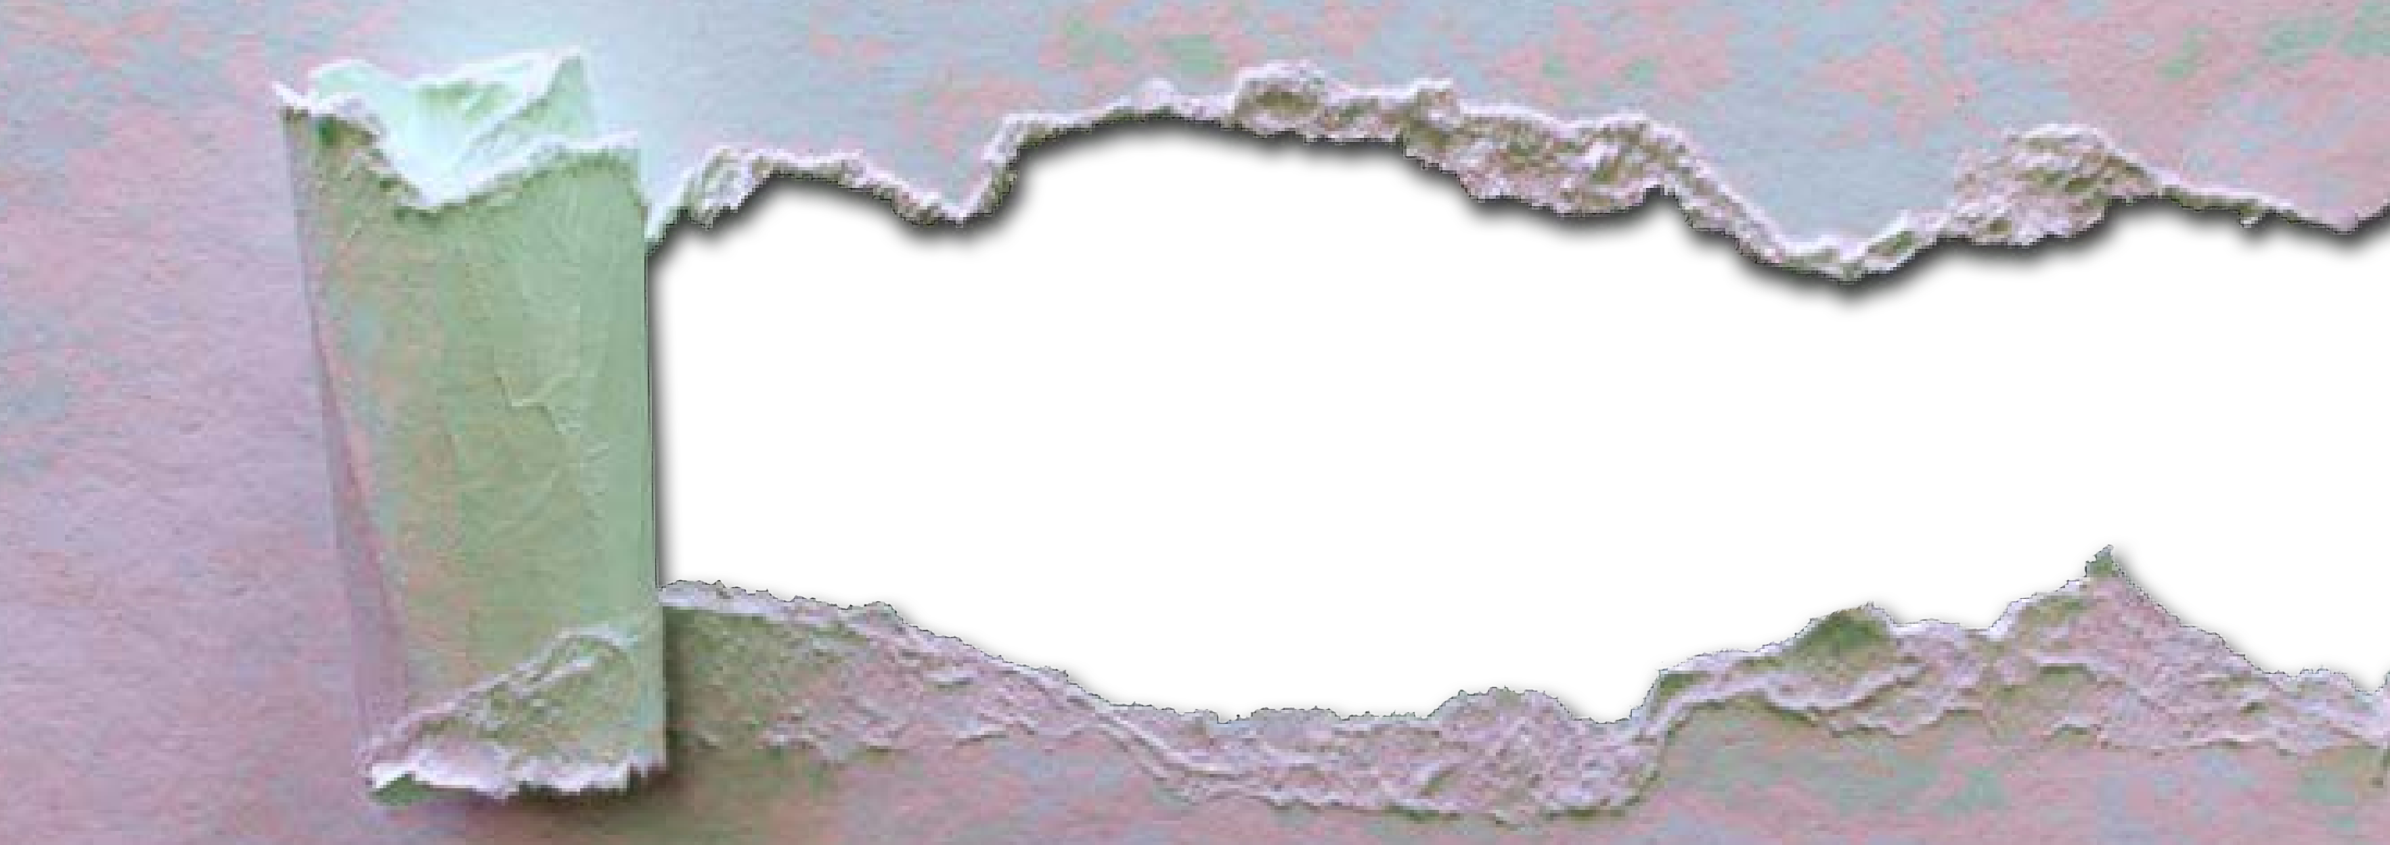

POCKET IMAGES

**Where can I find a catalogue of images without violating copyright laws?**

Google allows to search for images without copyright. After typing one or two key words in the search bar, click just below on «Tools», on «Usage Rights» and then on «Creative Commons License».

This topic is rather complicated and tedious, it would definitely need to be further explored elsewhere. Here we may only highlight the following websites, which offer high quality non copyrighted images.

1) Pixabay (with a catalogue containing almost two million images): **https://pixabay.com/it/**;

2) Pexels (with the possibility of searching by colour): **https://www.pexels.com/it-it/**

3) Unsplash (offering a great variety of images, as long as they aren’t used for marketing purposes.): **https://unsplash.com/it**

4) Gratisography (emphasizing quality over quantity): **https://gratisography.com/**

5) Kaboompics (an actual artistic portfolio): **https://kaboompics.com/**

6) The Noun Project (an online library of icons and symbols): **https://thenounproject.com/**

**How can I delete the background from images?**

All you have to do on Word is select the image, click on the top right on «Picture Format» and then «Remove Background». For a more precise result go to **https://www.remove.bg/it** instead.

Go to **https://giphy.com/**, search for what you need, copy the gif and paste it on the document you’re working on.



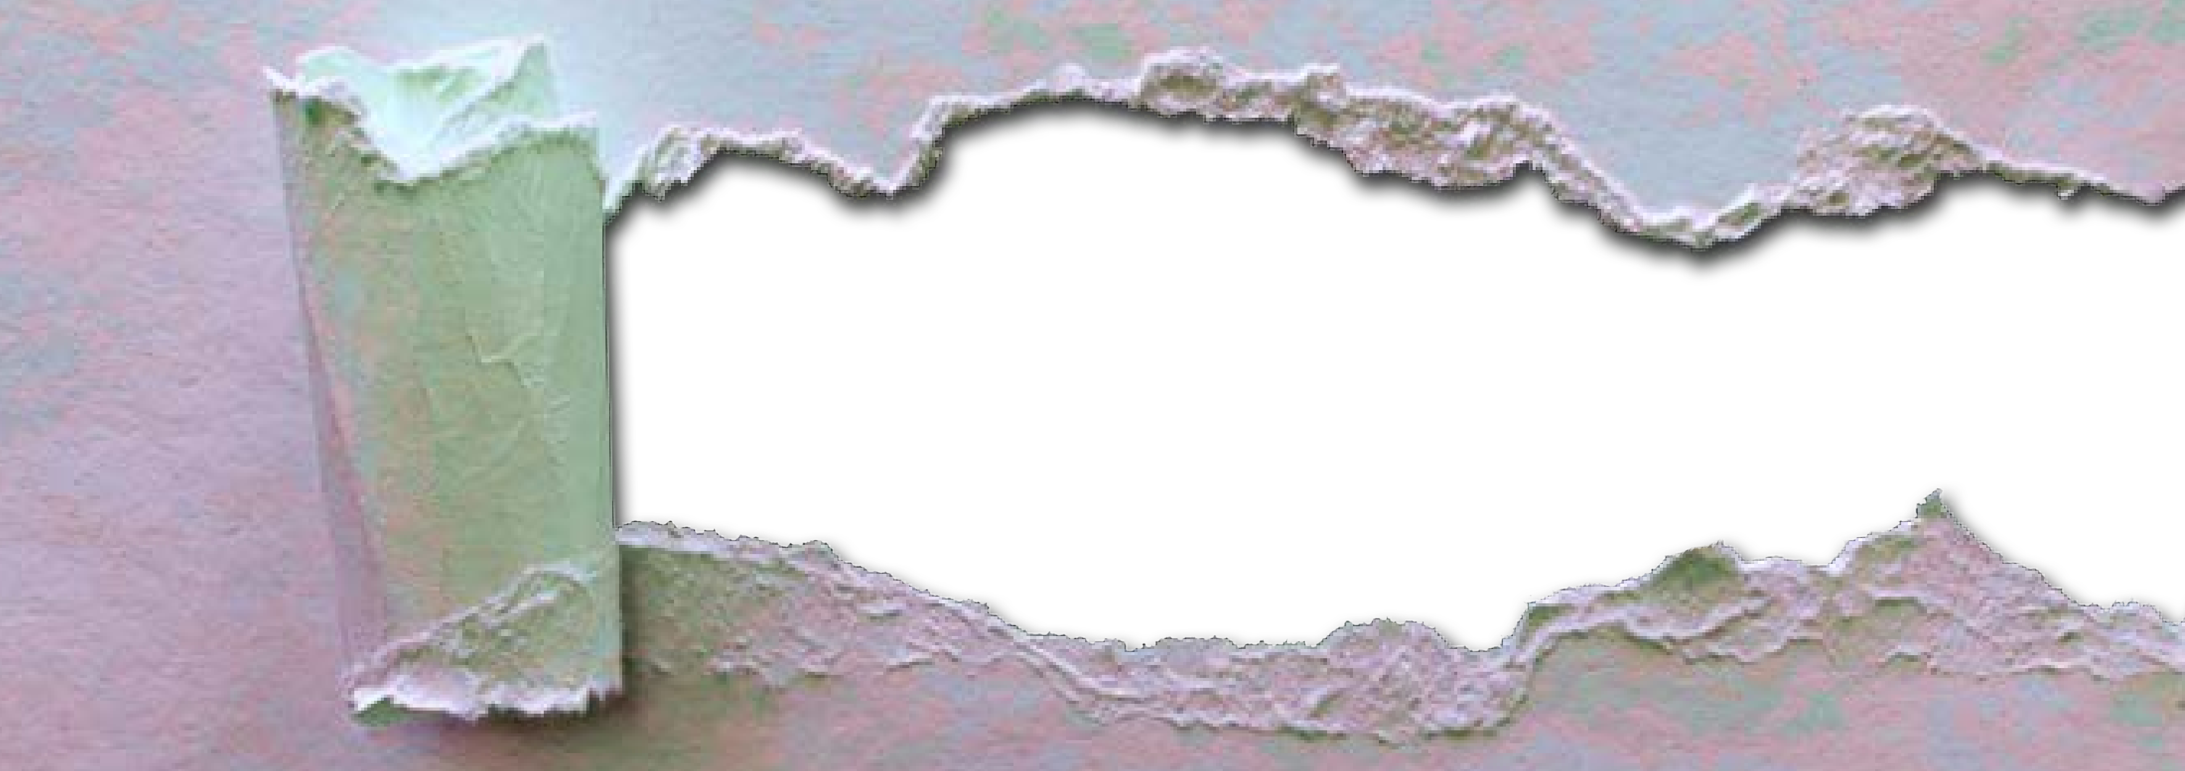

POCKET FONT

**Where can I find original fonts?**

On <https://www.dafont.com/it/> you can customize the font of your story in several different ways. Choose one of the many themes you can find on the website (fonts of all kinds: horror, retro, Greek and Latin alphabets, medieval, pixelated, Christmas-themed, etc.) and then click on «Download»

Open the file and use the preview version. Decompress the file and open it. Then click on «Install». The font will be automatically load onto all programs on your PC using texts. However, before you start using it, I recommend closing the program you use to write and reopening it. The font library will be updated.

Here are five examples. Which one would you use for a Dante’s Inferno-themed Escape Room? Which one reminds you of the logo of the famous TV series Squid Game?

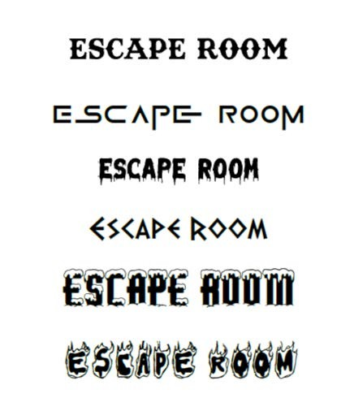

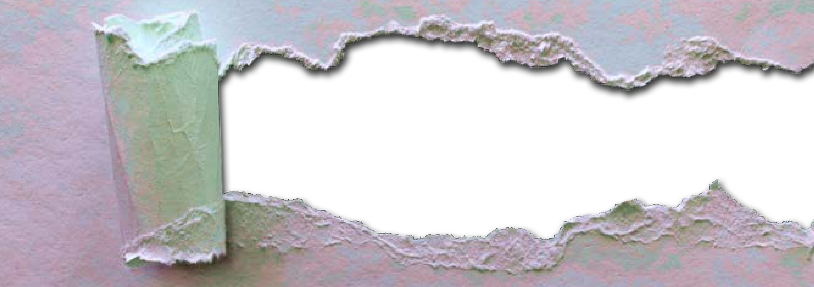

POCKET АCCESSORIES

**How do I create a false identity for my students?**

Visit <https://it.fakenamegenerator.com/>, select a gender, a home country and then click on «Generate». You can even select an age in the advanced settings.

**How can I create a fake ID or credit card?**

On <https://www.festisite.com/> you can create and print credit cards, marriage documents, driver’s licenses and tickets, in an easily customizable way by clicking on «Instant Creativity» and then «Documents» on the vertical bar on the left.

**How can I access a series of codes without wasting too much time?**

The website <https://www.randomcodegenerator.com/en/home> (which is free and doesn’t rrquire registration) generates random codes – 100 numerical sequences, 100 complex passwords or 100 codes to use as distracting elements during the various steps of your Escape Room.

**How do I make a text less readable?**

If your aim is to invert or turn a text upside down, <https://www.boxentriq.com/> is what you need. In the «Text and Word Tools» section, click on «Reverse Text» or «Upside down text» to make the resolution of your puzzle more challenging or intriguing.

In order to write upside down, check out <http://www.en.fliptext.net> You’ll get something very similar to this in the blink of an eye.

**How can I create an optometric table?**

This website <http://www.eyechartmaker.com/> allows you to create an optometric table, similar to the one that your eye doctor uses during check-ups. Type in the text in the «Enter chart text here» box and then click on «Make the chart». Your image will be ready in a few seconds. Using the right click on your mouse, save it on your computer or copy it in your notes.

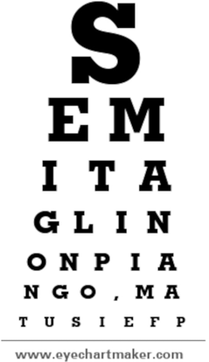

**How do I create digital locks?**

Lockee is a French web app – here is the link <https://lockee.fr/> – that is intuitive and easy to use. After registering, you’ll be able to create a new chain by clicking on «Create» on the top left.

You must fill in the first text box: insert the name of your lock. Scroll down to the bottom of the same page and click on type de locks.

Several options will be at your disposal. Here are some examples:

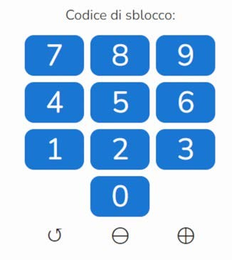 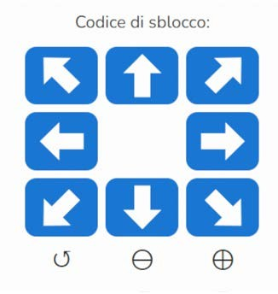

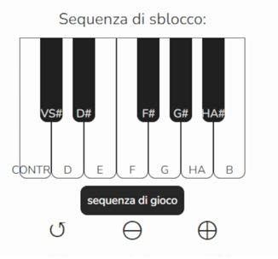

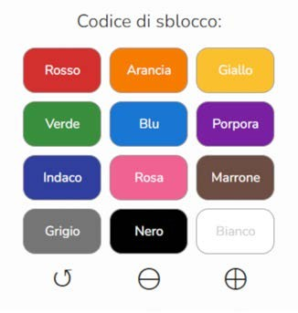

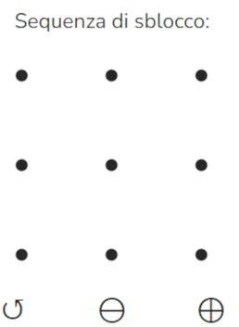 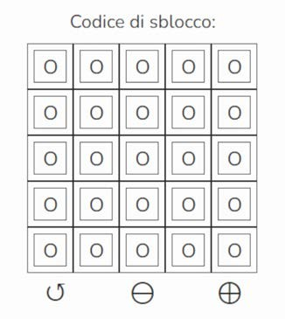

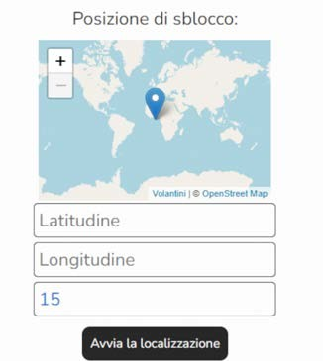 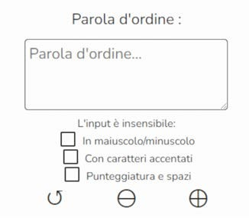

After choosing a chain type, click on the green button. A link, a QR code and an IFrame code to insert in your Escape Room will appear on the screen. On the top left, click on «Go» and you’ll see a preview of your lock.

**How do I create a fun and creative cypher code?**

The following cypher code comes from the short story “The Adventure of the Dancing Men” written by Sir Arthur Conan Doyle and then completed by the Danish scholar Aage Rieck Sørensen, who was passionate about Sherlock Holmes.

Visit <https://www.boxentriq.com/code-breaking/dancing-men-cipher> , copy the entire alphabet and distribute copies to your students (you can also find it below), and come up with a puzzle or a word to decipher following this famous cyphered alphabet.

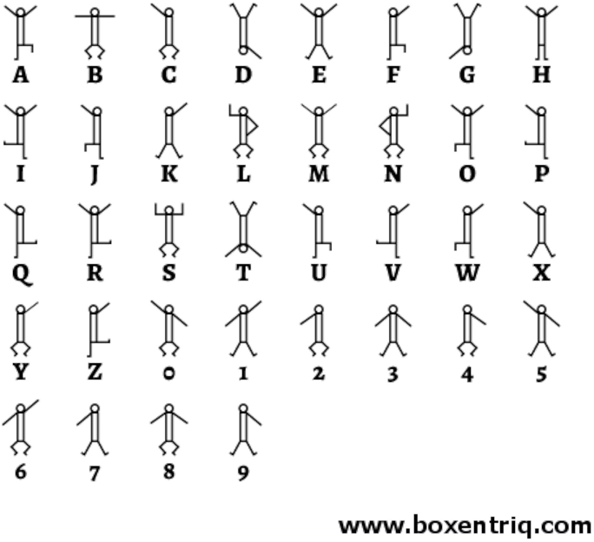

The website also allows you to use Morse code, a precursor of modern digital communication. Type the message you want to transcribe in the Translate Morse Code box and copy the content in the Translation window. Try to decipher the following message, using the image below:

--.- ..- .- .-.. .. / .--. . ... -.-. .. / ... .. / ... --- -- .. --. .-.. .. .- -.

--- / - .- -. - .. ... ... .. - ..--..

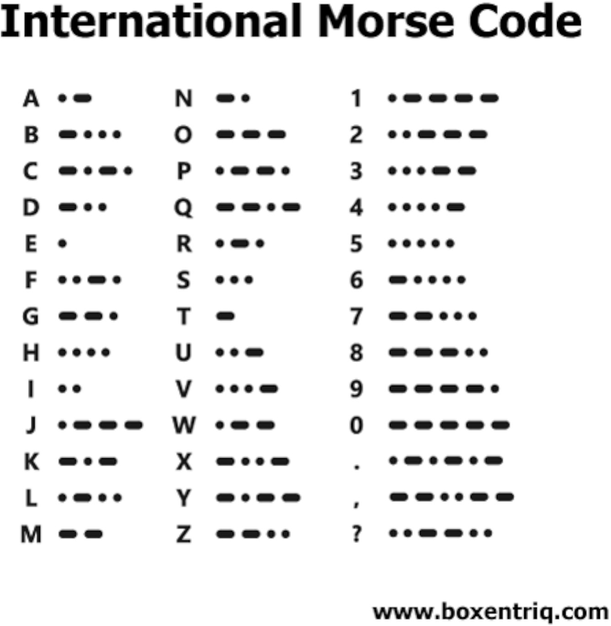

**Where can I find rhyming words easily and effectively?**

On <https://www.rimario.net/> you will find out that “heart” doesn’t exclusively rhyme with “art”, but also “depart”, “smart”, “start”, etc.

**Where can I find a website showing the real size of each country?**

This website <https://thetruesize.com> allows you to draw a comparison between the size of all the countries in the world – even the smaller ones - for free and without registration.

All you need to do is type the countries that you wish to overlap in the search bar on the left and drag them to the Equator. It can be useful to encourage your students with questions like «What’s bigger, Alaska or Brazil?» or «How many United Kingdoms would it take to cover the area of China?»

**What if they make too much noise?**

Mauro Sandrini, a professor of neuroscience based in Ravenna, has been promoting the use of the so called «Casinometro» (from the Italian “casino”, informal word used to refer to loud noise), a phonometer that measures the noise level created during class.

There are many of these available on the Internet, like <https://bouncyballs.org/> , recommended for primary school, or <https://youlean.co/online-loudness-meter/> , recommended for older pupils.

Of course I have to mention <https://classroomscreen.com/> too; it requires a teacher registration. This website has countless features, among which the creation of a phonometer (simply click on the Sound Level icon), a chronometer, a timer, traffic lights used to indicate the tolerable level of noise and different kinds of symbols.

Last but not least, I recommend the innovative <https://classroomzen.com/> , offering the same features.

POCKET PUZZLES

# 

**How do I create a digital maze?**

Here’s an example of a maze generator <https://www.mazegenerator.net>. Here you can choose the shape, style, width, height and the inner height and width. Click on «Generate New» and then on «Download». Here’s an example.

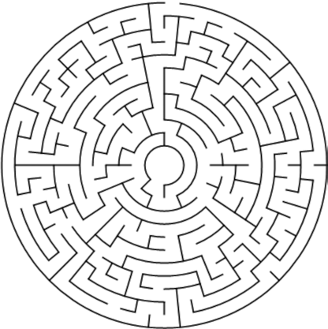

**How do I create a criss-cross puzzles and word search puzzles?**

This website <https://puzzlemaker.discoveryeducation.com/> allows you to create word search puzzles, math squares, maze puzzles in various shapes, cryptograms and different kinds of puzzles (such as letter tiles puzzles, number blocks puzzles and hidden message puzzles).

Now put yourself to the test!

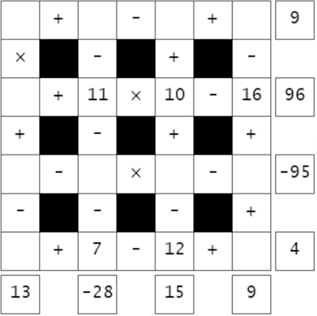 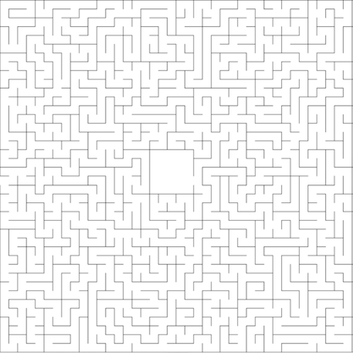

a) Math Squares b) Maze Puzzle



1. Letter-Tiles Puzzle

On <https://crosswordlabs.com/> you can alternatively create crosswords to either print or extrapolate as a link to add to your Escape Room, without having to sign up.

**How do I create a digital pairing game?**

Both with https://learningapps.org/ and <https://wordwall.net> , after registering, you can create a memory card game for your students.

In the first instance click – in this order – on «Create App», then «Pairing game» and then «Create new app». Below the «Pairs» section, add as many elements as the number of pairs you want your pupils to play with.

The pairs can consist of words or images. At the bottom of the page you will find the link and the QRCode.

In the second instance, click on «Create Activity» and insert in every box an image or a word that you want to transform into two cards to be flipped.

Afterwards, you may choose one of several themes (space, jungle, clouds etc.). Now click on «Share» and then «Publish». The link will then ready for you to use.

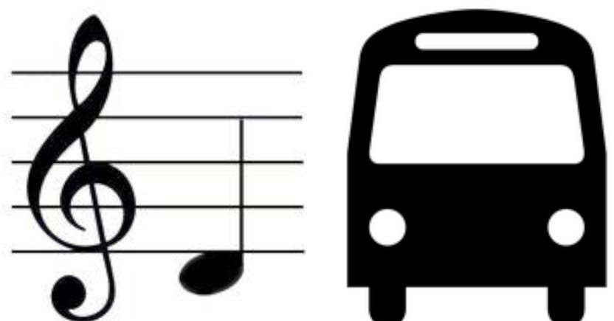

**How do I create a digital pairing game?**

Thanks Rebus Generator – this is the direct link <http://rebus1.com/en/index.php?item=rebus_generator> - you can create a rebus. Here’s an example:

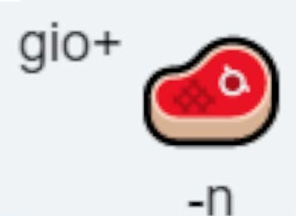

**How can I recreate the effect of invisible ink?**

After registering on Genially (<https://genial.ly/it/> ), go to the following website: <https://app.genial.ly/editor/63c673961402490011ea1d55?from=view_social> and choose one of the three coloured lenses available (red, green, blue) on the bar on the left.

Now edit the sentence at the first bullet point.

Ignore the other codes. Then click on «Share» at the top of the screen on the right, copy the link and paste it into your Escape Room.

**How can I make a puzzle starting from an image on my PC?**

After registering on Genially (<https://genial.ly/it/> ), visit the following link: <https://app.genial.ly/editor/62fea22eb17fda0018b7dc01> , click on the image of the globe and then on «Replace».

Select an image from your PC (or from Genially’s vast archive) and then choose, below on the left, how many rows and columns you want the image to be split into. The more rows and columns, the higher the number of pieces of the puzzle. Ignore all the other codes, click on the eye at the top on the right if you want to get a preview of your puzzle. If not, select share and paste the link into your Escape Room.

**How do I link an external URL to an image in my Escape Room?**

Click on the image loaded into your Escape Room on PowerPoint and then, to the right of the «Home» button, click on «Insert». In the middle you will find the «Hyperlink» and «Insert hyperlink» buttons.

Copy the link for the website and click on «Ok».

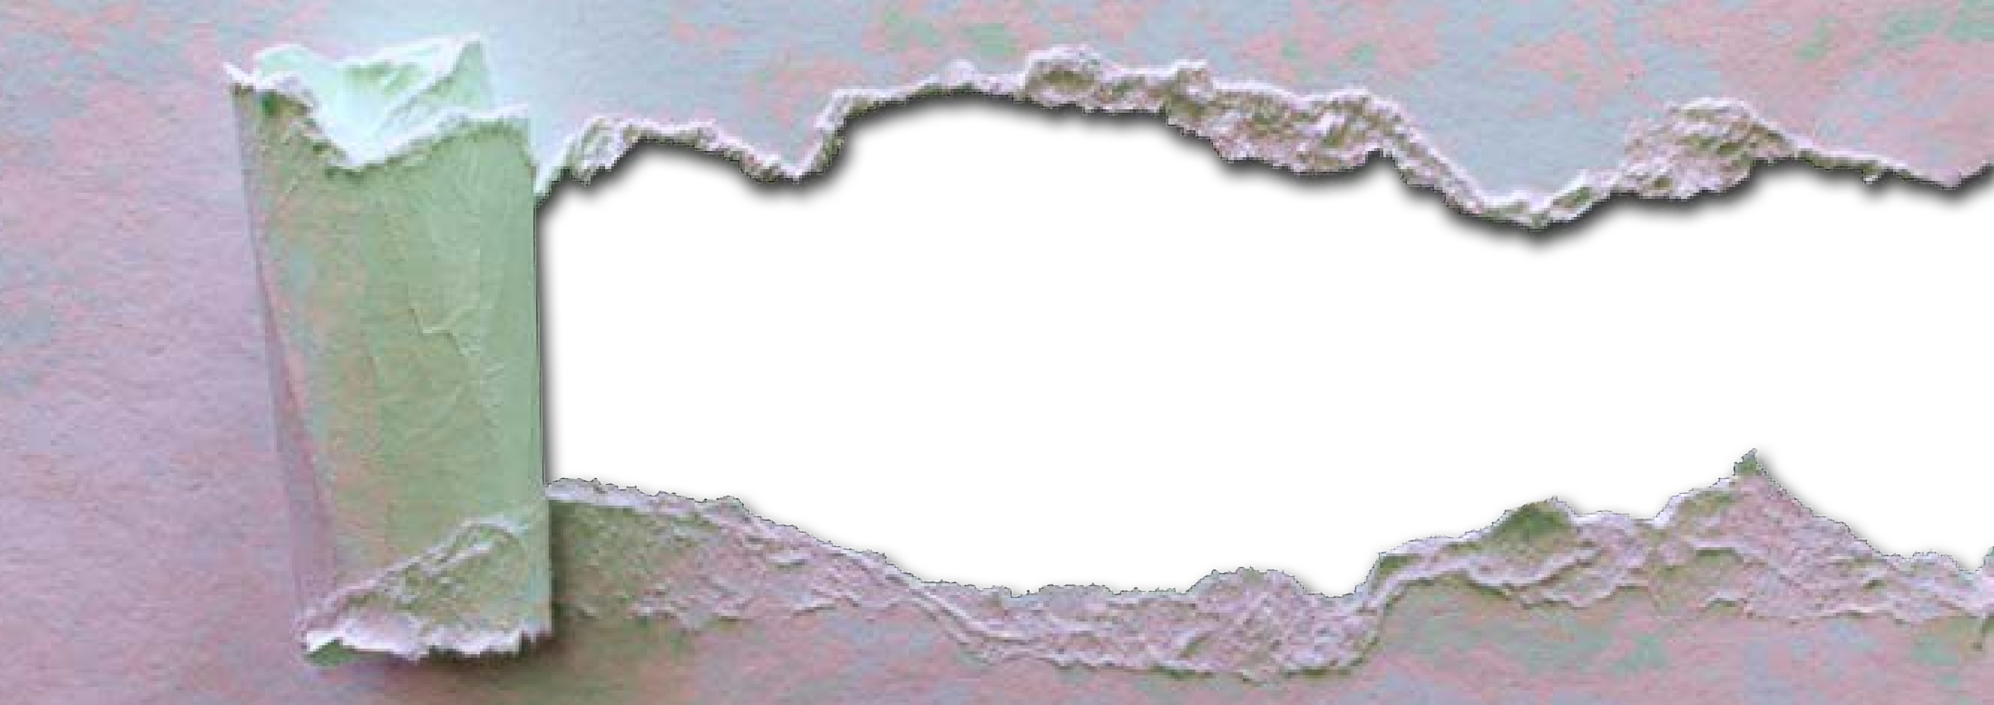

POCKET АUDIO

**Are there websites that I can use to modify my voice?**

123Appes – here’s the link https://123apps.com/it/ - it doesn’t require any credentials and it allows you to record audio tracks, which you can later edit and cut.

Scroll down until you find the section «Audio tools» and click on «Voice Recorder». Then save the file by clicking on «Save».

On the same page, in the «Audio Tools» section, the website allows you to modify the tracks in different ways. After uploading a track from your PC, you can change the volume, tone, pace and even invert the audio.

Sodaphonic is another useful tool – here’s the link <https://sodaphonic.com/> – which also offers the option of adding sound effects to your track.

**Where can I create talking avatars?**

On Voki – here’s the link <https://www.voki.com/> – you can create talking avatars. After registering, you can choose your character on the main page.

You can find ordinary characters, characters from fairy tales, mythology and animals. After choosing your character, you can edit their physical features or add clothes and accessories.

[https://express.adobe.com/express-apps/animate- from-audio/](https://express.adobe.com/express-apps/animate-%20from-audio/) is a valid alternative.



POCKET STORAGE

**Where can I find other Escape Rooms to draw some inspiration from?**

Professor Anna Maria Lorusso created a Padlet where she uploaded several Escape Room templates sorted by subject (from grammar to business economics).

Here’s the link for free access:

<https://it.padlet.com/annamaria_piccolalory/Escapers>